

|  |
| --- |
| **Design Brief** |

How is the overall increase in car fuel efficiency correlated to the decrease in pollutants in America?

**Project Title:** Data Project 3.2.7

**Client:** Brandon Hill, Ashkon Bashkar, anyone interested

**Designers:** Wesley Chan, Diego Santiago

**Problem Statement:**

Across the world, the growth of the electric car has tremendously increased. According to the EV volume website (Irle, R., Pontes, J., & Irle, V. (2016, August 1). EV.volumes.com. Retrieved February 1, 2017), there is a growth in electric vehicles by 55%. Yet, the fuel emissions of the regular everyday gas car still reign, with these emissions still prevalent the problem of pollution also remains. Pollution has been an economic problem since ten to forty thousand years ago. Since the industrial revolution and WWI, the significance of pollution has ultimately increased by 50%(European Environment Agency. (2015, February 18). Retrieved February 1, 2017, from http://www.eea.europa.eu/soer-2015/global/pollution), but with the invention of the vehicle, the rate has only increased. However, there are new innovations within the car industry. Instead of gas, cars are more reliant on electricity and even hydrogen fuel cells, while those cars that still use gas have become more fuel efficient. Ford has integrated a new system called Eco boost in their cars, making the car eco-friendlier, fuel efficient, and making less gas emissions. With such booms in technology for our cars, I believe that there is a correlation to the amount of pollutants in the world and the amount of more fuel efficient cars.

**Design Statement:**

The goal of their design for the 3.2.7 Data Project is to provide Brandon Hill, Ashkon Bashkar, and anyone interested in a theoretical portrayal of CO2 emissions in relation to newer eco-friendly vehicles. This design will include the effects of CO2 emissions on the environment, how cars have largely contributed to this, and how the newer fuel-efficient, eco-friendly vehicles are decreasing the yearly CO2 emissions. The design will also enhance the reader's knowledge on car’s contribution of CO2 emissions in the United States. These definitions will help define the ideas presented within the scatter plot. These definitions will also help define the idea that pollution rates have been decreasing due to the integration of eco-friendly and "Eco-boost" vehicles. With the integration of electric, and even hydrogen fuel cells, CO2 emissions will decrease with the new trend of environmentally friendlier vehicles. Finally, they will make the effort to make all the information available simple and understandable.

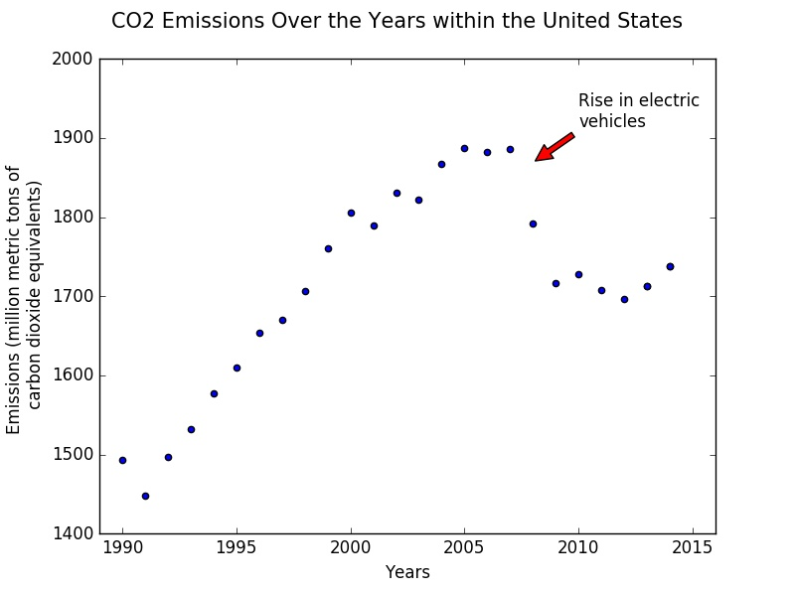

**Conclusion:**

The question they were asked was, “How is the overall increase in car fuel efficiency correlated to the decrease in pollutants in America?” The only way they revised the data is instead of looking at all “pollutants” they targeted CO2, carbon dioxide, specifically because gas fueled cars primary emission is CO2. The revised question would be, “How is the overall increase in car fuel efficiency correlated to the decrease in CO2 in America?” The result of the scatter plot graph showed the amount of carbon emissions, which is the primary gas expelled from cars, from the past 25 years starting in 1990. The outcome displayed a trend with the peak of the carbon emissions between the years 2005 and 2007 which happens to be right before the production of electric vehicles. After 2007, the carbon emissions fell due to the integration of electric vehicles, and air efficient transmission. However, it started to increase likely due to the increasing trend in these cars as well as being more affordable as before with greater selection.

(n.d.). Retrieved February 10, 2017, from https://www3.epa.gov/climatechange/ghgemissions/inventoryexplorer/#transportation/allgas/source/all